Volunteer Role Description 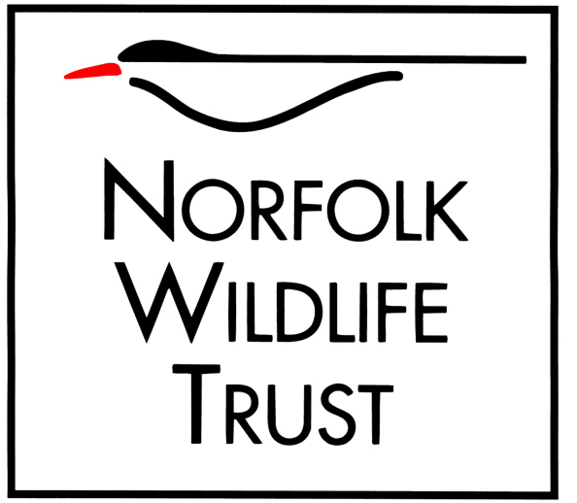

Role title
Wild Volunteer – Thorpe Marshes
Purpose of your role
To assist the reserve team with the management of NWT’s Thorpe Marshes nature reserve for the benefit of wildlife and visitors:

To help the wildlife of NWT’s Thorpe Marshes through assisting with habitat management.
To increase our knowledge of wildlife on the reserve through assisting with wildlife surveys.
To help visitors enjoy this site by helping with keeping pathways open and improving access.

Type of work you will be involved with
Practical reserve management using hand tools. Maintenance of footpaths and visitor facilities, and Fen restoration.
Assisting with species protection work on the reserve.
Helping carry out wildlife surveys.
Work will be supervised and under the direction of NWT staff and or / trained volunteers.
For volunteers with the necessary skills and training work could include the use of hand held power tools such as brushcutters if the volunteer wishes.

Skills and abilities you will be using in your role
Some interest, knowledge and understanding of the habitats and wildlife of the area will be of benefit.
Flexible, able to implement and undertake a wide variety of tasks under supervision of NWT staff
In reasonable health in order to carry out tasks to required standards (at your own pace).

You will be based at
NWT Thorpe Marshes

Times/days we would like you to be available
One day per month – on a Friday

Benefits to you
Opportunity to meet other people, enjoy the outside environment and see and learn about wildlife.
Opportunities to develop practical management skills
On the job training relevant to tasks undertaken
Become a valued member of a professional team
Knowledge that the work you do will benefit important nature reserves and the work of NWT
Opportunity to learn/enhance/share local knowledge of wildlife and conservation
Gain experience in a variety of different activities

Your supervisor
Mark Webster

Notes/special requirements
Must be prepared to work outside in all weather conditions
May be asked to assist with management of other wildlife sites on occasion.
Must be willing to comply with NWT Health and Safety policies and risk assessments.
Must be over 16 unless accompanied by a parent or guardian.
Must at minimum be fit enough to work outside doing light physical work.

