Volunteer Role Description 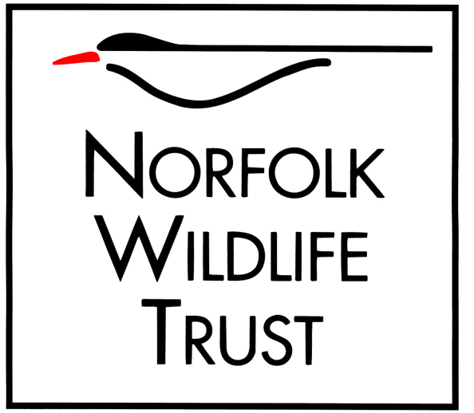
Role title
‘Showing People Wildlife’ Wild Walk leader

Purpose of your role
To raise interest in and awareness of Norfolk’s wildlife by showing members of the public around some of NWT’s wonderful reserves, including
- Upton Broad, an excellent place to see swallowtail butterflies, Norfolk Hawker dragonflies and marsh harriers
- Foxley Wood, famous for its bluebells, as well as an abundance of interesting plants, mammals, birds and butterflies, including white admirals
- Sparham Pools, with its lovely shaded circular walk, interesting plants and fungi, kingfishers and sandmartins, and butterflies including purple hairstreak and green hairstreak

The above are only examples - we are looking for volunteers to lead walks at many of our reserves that don’t have visitor centres, so if you live close to one of our reserves this could be a great opportunity for you to get to know it better and share it with others.

Type of work you will be involved with
- Helping to advertise walks on your chosen reserve(s)
- Leading walks on our reserves, and pointing out interesting flora and fauna to participants
- Giving people detailed information about interesting species of plants and animals, so enthusing them about wildlife
- Telling people what other wildlife watching opportunities are available to them locally
- Encouraging a caring and responsible attitude to wildlife viewing and support for wildlife conservation and the work of NWT

Skills and abilities you will be using in your role
- Ability to identify common wildlife, for example birds and butterflies – we can provide further training and information about the ecology and conservation interest of your chosen reserve
- Good communication skills
- Friendly, outgoing and confident in dealing with people of all ages
- Knowledge of and enthusiasm for wildlife and conservation
- Strong wildlife ID skills would be an advantage
- Ability to work alone and to use own initiative

You will be based at
NWT reserves across Norfolk (you won’t be expected to lead walks at more than one site which will enable you to get to know the reserve and its stories really well)

Times/days we would like you to be available
Flexible – you decide what days and times you want to lead your walks. We suggest running at least 4 walks per year. Monthly walks would be the maximum commitment.

Benefits to you
- Development of skills in interpreting wildlife in interesting and informative ways
- Opportunity to learn/enhance/share local knowledge of wildlife and conservation
- Volunteering at one of NWTs beautiful nature reserves, or at other locations in Norfolk
- Become a valued member of a professional team
- Travel expenses
- Training provided as required

Your supervisor :
Volunteer Coordinator

Other key NWT relationships
Reserve staff

Notes/Special requirements
Own transport and binoculars are desirable. This role is subject to a DBS check, and two references will be required.

