Volunteer Role Description 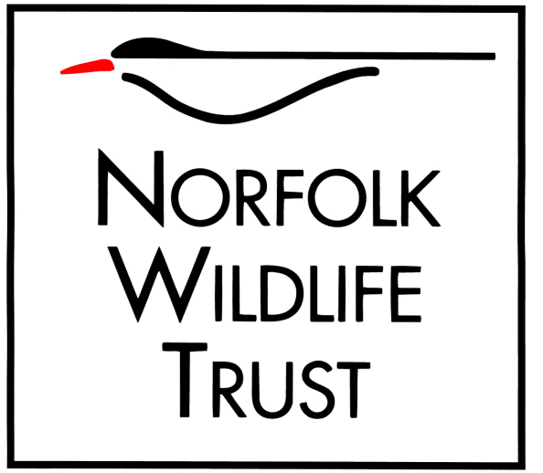

Role title
Nature Reserve Guide – Holme Dunes

Purpose of your role
To assist visitors in identifying birds and wildlife from the hides and on the reserve and provide information to visitors about the reserve and Norfolk Wildlife Trust.
Type of work you will be involved with
- Helping visitors to enjoy observing wildlife and assisting visitors with wildlife identification, especially birds.
- Bird identification - especially waders and waterfowl but also interpreting general wildlife on the reserve and pointing out interesting behaviours such as marsh harrier breeding displays.
- Possibly leading guided walks.

Skills and abilities you will be using in your role
- Competent bird identification skills e.g. you must be able to distinguish spotted redshank from redshank, black-tailed godwit from bar-tailed godwit, female pintail from female mallard etc.
- Good communication skills
- Friendly, outgoing and confident in dealing with visitors of all ages
- Knowledge of and enthusiasm for wildlife and conservation

You will be based at
NWT Holme Dunes
Times/days we would like you to be available -this can be flexible
One half or a full day per week.
Benefits to you
- Development of skills in interpreting wildlife in interesting and informative ways
- Volunteering at an internationally important nature reserve, which is one of Britain’s best for bird watching
- Opportunity to learn/enhance/share local knowledge of wildlife and conservation
- Become a valued member of a professional team
- Travel expenses (to be agreed in advance with the Visitor Centre Coordinator)

Your supervisor
Holme Dunes Visitor Centre Coordinator

Notes/special requirements

