Volunteer Role Description 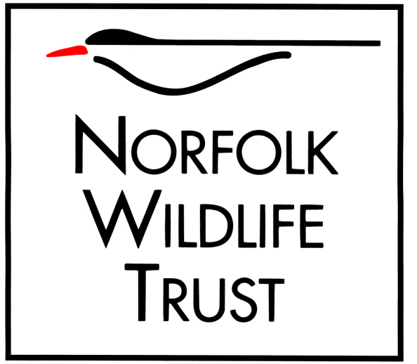

Role title/Location
Volunteer Beach Warden – NWT Holme Dunes

Purpose of your role
To protect, monitor and educate about vulnerable beach nesting birds like Ringed Plover, Little Tern and Oystercatcher here at Holme Dunes during their spring/summer breeding season.

Type of work you will be involved with
- Patrolling the beach near breeding and nesting areas to prevent disturbance by people and dogs and reporting any disturbances to the beach warden.
- Educating the public about the species and what we want them to do and why, to protect them.
- Recording species behaviour such as courting, breeding, nesting and reactions to disturbance.
- Monitoring nests, chicks and breeding success.
- Assisting with the maintenance of nesting habitat cordons where necessary.
- Assisting the beach warden with any other education events.

Skills and abilities you will be using in your role
- The ability to communicate with people from all walks of life in a friendly and tactful manner.
- An interest and enthusiasm for wildlife and nature.
- A willingness and enthusiasm to learn are essential, full training will be provided as well as ongoing support.

Times/days we would like you to be available
- This role is flexible, but at least one half-day a week is preferable.
- The role will be required from April until the birds have fledged (around September time).

Benefits to you
- Become a valued member of a friendly and enthusiastic team of like-minded people.
- Be a part of an important wildlife conservation project that will benefit declining species.
- Opportunity to learn or enhance your knowledge of coastal wildlife and conservation.
- Develop a range of people skills.
- Develop your species monitoring and data collection skills.
- On the job training and support.
- This role will be of particular value to those looking to enter the Conservation sector.

Your supervisor
Beach Warden, NWT Holme Dunes

Notes/special requirements
- Must be prepared to work outside in all weather conditions.
- Must be reasonably fit to patrol the beach.
- Tasks will be carried out in pairs/groups where necessary.
- NWT will reimburse you for your travel expenses to NWT Holme Dunes.
- All necessary uniform and equipment will be provided.

